SA5 Outbound – Research and concept

Key findings for the team
A shared AI platform with predictions is not self-organising on its own. SA5 must add bounded decisions and coordination between departments, with a clear route back to the planner.
- Article: Gerrits, van Heeswijk and Mes (2024), International Transactions in Operational Research. It is a systematic review of 169 studies on self-organising logistics (SOL) in transport.
- What SOL means: some decisions are delegated to autonomous assets, which cooperate with each other. Mixed central and decentral control is common and realistic within one company.
- The evidence is still young: 115 of the 169 studies stop at simulation, and only 5 describe a system in daily use. Few compare self-organising and central planning on KPIs, so our benefits remain hypotheses.
- A gap we can fill: only 4 of the 169 studies define when humans step in. Our design sets out what the AI may do alone and when it hands a decision to the planner.
- Where we sit: FreshWay today and our SA4 design are low on both autonomy and cooperation. SA5 takes the step the article calls lowest-risk: more cooperation across departments, while the AI's own decision room stays small.

1.1 The article
We used Gerrits, van Heeswijk and Mes (2024), a peer-reviewed, open-access review in International Transactions in Operational Research. It covers transport logistics, the area closest to Outbound.
Why this article. It is recent (online December 2023, in print May 2024) and the authors are from the University of Twente. Its main contribution suits our assignment: a common language for describing how self-organising a logistics system is.
Their definition. SOL is a logistics control system that delegates at least part of its decision-making to intelligent, autonomous assets through decentralisation. Assets can be trucks, containers, storage locations or whole organisations. Some central control is allowed; fully central planning is not SOL.
Method. The authors searched Scopus on 24 May 2023 and found 553 papers. After screening, 169 studies published between 1994 and 2023 were analysed. They classified each study on five points:
- the logistics application;
- how far control is decentralised;
- the type of intelligence used;
- how far the work is validated and how mature it is;
- a self-organisation score from 0 to 4, set by the authors.
From this, they built a typology of 15 characteristics and a framework with two axes: autonomy and cooperativeness.

1.2 Key findings
Self-organisation means two things together: assets make some decisions themselves, and they coordinate with each other. Most research applies it to operational transport planning, and most still mixes central control with local decisions.
- Potential benefits. The reviewed studies report faster decisions and less data sharing, along with better scalability and adaptability. One cited study reports performance close to central planning. The downside is emergent behaviour, which makes the system less predictable and harder for managers to accept.
- Mostly daily operations and trucks. Of the 169 studies, 140 address operational decisions, 78 concern trucks, and 101 delegate transport planning. This matches Outbound's daily route planning.
- Mixed control is normal. 73 studies use decentral control, 55 hybrid and 41 central. Central control steps in when local units cannot agree, behave chaotically or reach the limit of what they can decide. The authors call this realistic, especially within one company.
- "Agent-based" does not always mean self-organising. In 44 studies, agents only split a central problem into parts. Decisions then remain central, so there is little real self-organisation.
- Coordination is the key step forward. Most studies give assets autonomy but little cooperation. The best examples combine both, often across company or department boundaries.
- Humans are largely missing. Only 4 studies define when humans or a central level take over. The authors call the role of planners, the IT component and escalation neglected.
The framework. Autonomy runs from critical (safety tasks only) through rudimentary and constituent to self-governing. Cooperativeness runs from individual through brother (same kind of assets) and team (other functions within one organisation) to societal (beyond the organisation). The two axes give four categories, shown in section 2.1.
One category matters for us. The One-Trick Pony combines low autonomy with high cooperation. The authors describe it as a safe first step for systems that are low on both axes, because the AI's own decision room stays small.

1.3 Limitations and evidence tier
The article is strong evidence of what researchers have studied, but weak evidence that self-organising logistics works in daily practice. It also does not test anything at FreshWay.
Limitation | What it means for us
Little real-world evidence: 115 of 169 studies stop at simulation, 13 validate in the real world and 5 describe a system in daily use | We cannot cite the review as proof that our design will work. A pilot is needed.
Few studies compare self-organising and central planning on logistics KPIs | We cannot claim gains in punctuality, OTIF or cost per roll cage. Francesco's evaluation must compare against current planning.
The self-organisation score (0 to 4) and the framework positions are the authors' own judgement; they call the quadrant borders far from rigid | Our placement in section 2.1 is a reasoned estimate, not a measurement.
The search ran to May 2023 and excludes papers that only study IT components | The newest platform and AI developments may be missing, and so is detail on how a shared server is built. Made's section has to rely on other sources.
The review covers transport broadly, not grocery replenishment to stores with narrow delivery windows | Transfer to our 22 ZE stores is an argument we make, not something the article shows.
Human roles and escalation are rarely studied (4 of 169) | The article offers little guidance on boundaries; we design them ourselves and test them in the pilot.
One more caution: the authors see self-organisation thriving where many parties share little information. FreshWay is one company with largely central data, so our case rests on faster decisions and coordination between departments, not on missing information.
Evidence tier. Tier 1 by our working definition: a peer-reviewed systematic review in an established operations research journal, with a stated search method. That makes it a reliable account of the research field. It does not show deployment: peer review proves the method was sound, not that the systems work in practice. Check this against the course's tier criteria before submission.

2.1 Concept: from prediction to bounded self-organisation
Outbound becomes partly self-organising only when software agents on the shared platform take small decisions within boundaries the department sets, and share their plans with connected departments. The shared server and the predictions are inputs; they do not make the system self-organising.
Why a shared server or prediction alone is not self-organisation
- A shared server is central infrastructure. It hosts models but takes no decisions, so on its own it adds neither autonomy nor cooperation.
- A prediction is analysis. If every decision still goes to one central planner, the structure stays central, just with better information. This resembles the 44 studies where agents only split up a central problem (Gerrits et al., 2024).
- Self-organisation needs both axes: decisions delegated to assets (autonomy) and interaction between them (cooperativeness).
Three building blocks we add (proposal)
- Trip agents. One software agent per planned trip runs on the shared platform. It watches its own arrival-risk and unloading-time predictions from SA4 and reacts when the risk changes.
- Decision boundaries. The Outbound department sets rules for what an agent may do alone. Anything outside them goes to the planner, who acts as the central fallback that hybrid systems in the review use.
- Coordination through shared information. Agents publish updated departure and arrival times on the platform, and connected departments can use them. The review calls this indirect coordination through a shared environment stigmergy. What other departments need must be requested from them, not assumed.
Where we sit. The figure below places FreshWay today and our SA4 design in the Quiet One quadrant: low autonomy, low cooperation. SA4 improved the information but not the decision structure. The SA5 proposal moves to the One-Trick Pony: agents share plans across departments, but their own decision room stays rudimentary. More autonomy is a possible later step, only if pilot results support it.
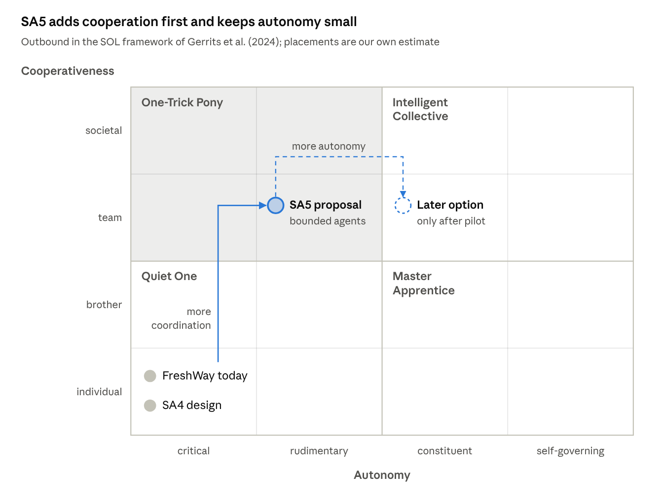
Outbound in the SOL framework · autonomy × cooperativeness
SA4 only improved information, so it stays in the Quiet One. SA5 adds coordination first; more autonomy (dashed) waits for pilot evidence.

2.2 Application to Outbound on the shared AI platform
On the shared platform, Outbound runs its own models and trip agents. These handle routine, low-risk steps alone and escalate anything that changes a route, a store delivery or another department's work. Everything below is a proposal; nothing of it exists yet.
How it coordinates and adapts
- Sense. The platform receives route plans from the TMS and historical deliveries. Once the paid API is in place, it also receives live truck positions.
- Predict. Outbound's models update arrival risk and unloading time for every stop (SA4 use cases 1 and 2).
- Check. Each trip agent compares its situation with the boundaries the department has set.
- Act or escalate. Inside the boundaries, the agent acts and logs what it did. Outside them, the planner gets ranked options with their predicted effects.
- Share. Updated departure and arrival times are published for connected departments, insofar as they have agreed to receive them.
- Learn. Outcomes and planner decisions are logged. Models are retrained; the boundaries themselves change only by decision of the Outbound department after evaluation.
Decision boundaries (for Made to finalise)
Decision | In the pilot | Later, only if the pilot supports it | Conditions
Update predicted arrival and late/early risk per stop | Agent, automatic | Agent, automatic | Information only; no change to the plan
Alert the planner when late risk passes a threshold | Agent, automatic | Agent, automatic | Department sets the threshold
Tell a store its updated arrival time | Planner approves | Agent, automatic | Channel agreed with stores; store restrictions (C10) checked
Share updated departure with Orderpicking, or charging need with Storage | Planner confirms | Agent, automatic | Each department states its requirements and agrees the interface first
Depart 5 minutes earlier on a trip not yet departed | Planner approves | Agent, within limits | All stops within windows, low early risk, truck, driver and charging available, no C3 or C10 conflict, reason for the 15-minute offset known
Larger shift or a different stop order | Planner | Planner | Affects several stores; always escalated
Changes for trucks already on the road | Planner | Planner | Agent may suggest; driver contact stays human
Platform down, model unavailable or data stale | Planner plans manually in the TMS | Same | Fallback to the current way of working
Outbound in the typology of Gerrits et al. (2024)
Characteristic | SA4 design | SA5 proposal
Control hierarchy | Central: planner and TMS | Mostly hierarchical (hybrid): agents take small steps, planner above them
Decision-making method | Learning (predictions); human decides | Learning (predictions) plus rule-based boundaries
Location of decision-making | Central | Mostly central; routine steps local
Location of data | Mostly central (TMS, history) | Mostly central, plus live truck data once connected
Interactions | None between assets | Exchange of information through the platform
Openness | Closed | Open to data from connected departments, if agreed
Degree of control delegation | None | Some
Predictability | High | High, because boundaries limit what agents do; to be verified in the pilot
Ease of technological implementation | Medium to high: builds on the existing TMS | Low to medium: needs the platform, interfaces and agents

2.3 Input for the impact map (for Scholte)
Each row follows the chain technology → behaviour → effect → value for one stakeholder. Effects are hypotheses to test. Values are FreshWay targets, not promised outcomes. Rows for other departments describe proposed exchanges that still need their requirements.
Stakeholder | Technology | Behaviour | Effect (hypothesis) | Value
Outbound planners | Trip agents and predictions on the shared platform | Handle escalations and approve options instead of checking every trip | Earlier action on at-risk ZE trips; workload shifts from monitoring to exceptions | ZE punctuality, now 87.5% on time against 98.4% elsewhere; supports the OTIF target of 98.5% (now 97.2%)
Drivers | Approved changes sent to the board computer | Depart at the adjusted time; follow an approved new stop order | Changes known before departure instead of on the road | Feasible routes, less time pressure
ZE stores | Updated arrival time (proposed; channel to be agreed) | Plan receiving staff around the predicted arrival | Less waiting and fewer late arrivals | Shelves stocked on time; depends on C10
Orderpicking | Updated planned departure (proposed exchange) | Adjust picking or loading order, if feasible for them | Roll cages ready for earlier departures | Earlier departures without loading delays; to confirm with Orderpicking
Storage | Charging need when electric-truck departures move (proposed exchange) | Plan charging slots earlier | Electric trucks (8 of 54) ready for shifted ZE departures | Feasible ZE routes
Inventory & SCM | Delivered quantity and arrival time per delivery (existing flow) | Compare delivered with required quantities | Full OTIF becomes measurable, not only punctuality | Reliable OTIF reporting
Central IT | Hosting Outbound models and agents on the shared platform | Manage access rights, monitoring, updates and fallback | Shared support and cost; risk of resource contention and outages | Reuse across departments; who pays is still open
FreshWay management | Decision on the shared platform and the Outbound pilot | Approve boundaries; review pilot results before allowing more autonomy | Decisions on autonomy based on evidence | Cost per roll cage target €7.00 (now about €7.73); no savings assumed

Sources
One peer-reviewed article carries the research; all FreshWay figures come from the case documents and delivery data analysed in SA3. Working tier definition: Tier 1 is peer-reviewed research or primary company data, Tier 2 is reputable industry or government reporting, Tier 3 is vendor material, blogs or opinion. Match this to the course criteria before submission.
Source | Tier | Why this tier | Claim it supports
Gerrits et al. (2024) | Tier 1 | Peer-reviewed systematic review with a stated search method, in an established operations research journal. Shows the state of research, not deployment: 5 of 169 studies describe a deployed system | Definition of SOL, findings, typology, autonomy and cooperativeness framework (all sections)
FreshWay case documents and delivery data | Tier 1 | Primary company data, analysed in SA1 to SA3 | ZE punctuality, OTIF and cost per roll cage, fleet, existing information flows (2.2, 2.3)
References (APA 7)
FreshWay. (n.d.-a). Company dossier [Unpublished case document].
FreshWay. (n.d.-b). Department file: Outbound transport [Unpublished case document].
FreshWay. (n.d.-c). Store replenishment delivery data [Unpublished data set].
Gerrits, B., van Heeswijk, W., & Mes, M. (2024). Towards self-organizing logistics in transportation: A literature review and typology. International Transactions in Operational Research, 31(3), 1309–1374. https://doi.org/10.1111/itor.13408

